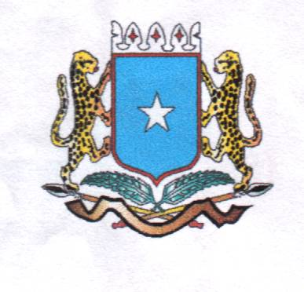
Puntland State of Somalia dDawladda Puntlan
Ministry of Education
Wasaradda Waxbarashada

GENDER UNIT

“EDUCATION IS THE CORNERSTONE OF A STRONG COUNTRY. LET US SEND BOTH OUR GIRLS AND BOYS TO SCHOOL”

NATIONAL GIRLS EDUCATION MEDIA CAMPAIGN

CREATING AWARENESS ABOUT OPPORTUNITIES AND CHALLENGES BEING FACED IN UPLIFTING THE QUALITY OF EDUCATION FOR GIRLS IN PUNTLAND

FINANCED BY UNITED NATIONS CHILDREN’S FUND (UNICEF)

IMPLEMENTED BY THE MINISTRY OF EDUCATION PUNTLAND

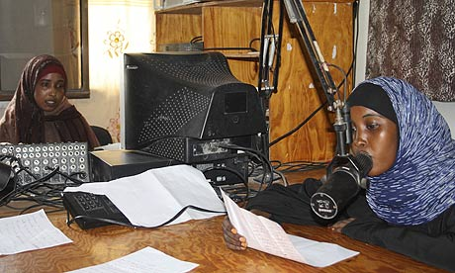

FACILITATED BY RADIO DALJIR, RADIO GAROWE
& SBC TELEVISION IN COLLABORATION WITH THE GENDER UNIT
OF THE MINISTRY OF EDUCATION

1ST May 2011 -30TH SEPTMEBR 2011
Garowe, Puntland State of Somalia

- INRODUCTION BACKGROUND
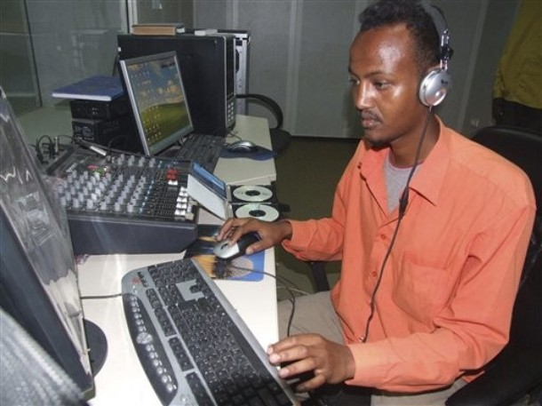
Between August and November of 2011 the Ministry of Education in Puntland with the financial support of UNICEF implemented a Media Campaign program The goal of the media messages was be to promote girls’ education create awareness about the obstacles they face in accessing, retention and completion of education. The campaign targets parents (to encourage them to send their daughters to school), girls (to encourage them to want to go to school), the community (to support girls’ education in their communities). Different media were invited to engage in the campaign and contracted by the Ministry of Education in Puntland to facilitate this project. The campaign started in April of 2011 and it is to end in late November of 2011. The media campaign, with its different components was a very successful one because of the different media sources used for the campaign and also because of the number of people who contributed to the lively debates both on TV and radio. For this purpose we would like to thank all those came to attend the debates, who gave interviews and all those who took the panel. We also had many people who called the radio stations because they had questions or contributions. Radio Daljir has an FM signal that is heard throughout north Puntland and the gulf coast all the way to the coastal cities of Yemen and the Sultant of Oman.
The prolong absence government has affected the education systems and its quality of in the whole country. With the help from unicef and the ministry of education,daljir has actively facilitated in airing the program through out all the fm stations in puntland. Daljir has successfully facilitated many different projects from different donars through the radio, because it si the largest net work of fm stations throughout the horn with coverage of allpuntland. Parts of Somali and, central regions of Somalia We have worked with the United Nation’s UNESCO Civic Education Program for Peace, Democracy and Development in Somalia supported by various international organizations and multilateral donors including UNDP, European Union, and the Italian government. The UNESCO project in order to help create an effective agent of behavioural change helped “establish a healthy interaction between three important elements of the Somali society: the state or local governments, the civil society and the Media.” Among other important issues, it helped “establish interaction between traditional leaders, youth, militia and religious groups on social, cultural and educational endeavors in Somalia, with special reference to articulation of women's visions of a culture of peace,” long-staying hu

2.1GOALS AND OBJECTIVES OF THE MEDIA CAMPAIGN
This activity falls under the Gender Unit workplan. Specifically it falls under the Social Mobilisation and Media Campaign advocacy activity. The goal of the media messages will be to promote girls’ education create awareness about the obstacles they face in accessing, retention and completion of education. The campaign targets parents (to encourage them to send their daughters to school), girls (to encourage them to want to go to school), the community (to support girls’ education in their communities).

2.1 How will the messages be disseminated?
· Through radio such as telling a story, debating, talking about its benefits.
· Drama, concerts, skits,
· SBCTV: Poems read on radio, or on community drama.

2.2 What kind of messages were sent out

The media messages on girls’ education evolved around the following themes:

- Increased Job Opportunity: In today’s job market, most employers require more than a high school diploma. Send your daughters to school!
- Better Salary: The more education a girl has, the greater potential she has to earn a good income. Educate your daughters, send them to school!
- Life Experience: At school girls learn important life skills such as living in harmony with others, time management, discipline, budgeting money and meeting other people. These skills will prove valuable in your personal life. Educate your daughters, send them to school!
- An educated mother, a health family: Going to school and getting an education is a weapon against disease, bad hygiene and poverty. An educated mother produces an educated family and an educated family is a healthy family.
- Meeting people that can be important in your life in future: You’ll make lots of friends and form relationships with people who may prove helpful during your professional life as an employee or business person or even parent. Your peers could become business partners or people to reach out to in the future.
- Opportunity for personal growth: Education provides opportunities for personal growth in knowledge and understanding and improves women’s participation in public life. These days, there are women ministers, lawyers, doctors, teachers, and business people. Educate your daughters, send them to school!
- Sense of Accomplishment: Going to school, remaining and progressing through education gives one a sense of accomplishment and achievement. You explore your skills and are able to do many interesting things in life.

2.3 Advocacy media messages on the value of education (in life in general) with Somali version

1. Education is my life. My life is education. I go to school to grow in mind and body. Give me a chance to learn.
Waxbarashadu waa noloshayda. Noloshaydu waa waxbarasho. Waxaan aadaa iskool si aan kor ugu qaado aqoontayday iyo maxkaxdeyda. Isii fursan aan wax kubarto.
2. Education is like food, no one can chew it for you. Let girls go to school.
Waxbarashadu waa cuntoo kale, majirto cidkuu calalineysa. U ogolow gabadhaada waxbarasho.
3. A child learns well when they are with other children. A child belongs to the community. So send your girl to school.
A cunuggu wuxuu sifiican wax ubartaa marku arkayo cunug kale oo waxbaranaya. Cunuga waxaa leh bulshada. Udirgabadhaada waxbarasho.
4. Education is like fruit tree that produces many delicious fruit. You must plant it early, so send your daughter to school. You will reap the fruit of her education.
Waxbarashadu waa miroha geedko kale kuwaas oo miro kale dhalaya. Waa in aad beertaa, udir ninantaada waxbarasho, mirahay beertaad gurane.
5. Education means a good life for the girl, her family and her community. Let us send our girls to school.
Waxbarashadu waa nolosha wanaagsane gabadha bulsha ahaan iyo reerkeedaba, aan waxbarno gabdheehana
6. Educating only boys is good, and walking on one leg only can be good. Educating girls is better. It’s like walking on both legs instead of leaping only on one leg. It brings out a balance in life.
Hadaa wiil waxbarto waad fican tahay laakiin hal qofbaa waxbartay hadaa gabar waxbarto se labo qofbaa waxbartay iyo kabadan
7. Education is like seeing. When you educate a boy only, it is like seeing in one eye only. When you educate boys and girls, it is like seeing with both eyes and you see more clearly.
Waxbarashadu waa ileys, markaa wiilkaliya wax barto hal ileysbaa shiday markaa gabar iyo wiil waxbartanaha labo ileys baashiday si aad sifiican wax ugu aragto.
8. When you do not send girls to school it is like building a house with one hand only. When you educate boys and girls, it’s like using two hands to build. Let’s build our country, our community, and our families. Let’s educate both boys and girls!
Marka wiil kaliya waxbarto waxay udhigantaa adoo hal gacan ah guri kudhisay laakiin markaa gabar iyo wiil waxbarto waxaad isticmaashay labo gacmood si aad guri udhisto, aan dhiso wadan keena, bulshadeena, reerkeena inagoo waxbaraynah gabdho iyo wiilalba caruurteena.

EXAMPLES OF SHORT STORIES

Dramatization of a situation that is commonly seen:
An example could be an imaginary situation that reflects true life. E.g. an illiterate mother takes her child to the doctor. The pharmacist writes on the bottle: (Take this 2x3 a day) and the mother gives her child the whole bottle at once, with deadly consequences.
A situation can compare two families:
In one community, the Gender Focal Point talked to parents in a community to send their daughter to school. One family agreed to do so, while the other refused, saying educating girls has no value. There is famine in the land and both families are affected. Girls from both families go out in search of work. The one who has gone to school finds employment with an NGO, while the other one does not get a job because she did not go to school and does not know how to read and write.
The girl who got a job is able to help the family to buy food, send other children to school and pay for her parents’ treatment in hospital. The family of the other girl continues to suffer.
Employment
The MoE is looking for boys and girls to collect data during the school survey. The MOE wants to employ two girls in one village, but no girl has gone to school. Ten girls went to school in the last three years but dropped out of class two. MoE wants people who can read and write but cannot employ girls from that community because they did not go to school.
Difficult life circumstances
One girl was married to a high school teacher after her parents forced her to leave school. After five years of marriage and two children, the husband left the woman with her children. Her parents had left for Kenya due to drought and she had no one to turn to. Her friend, who did not drop out of school has been employed by a local NGO and is able to help her family. She wants to help her friend so she asked the local NGO to employ her to stop her suffering. The NGO wants someone who can read and write. Since her friend cannot read and write she cannot get a job and continues to suffer.
SLOGANS/SAYINGS/PROVERBS TO INSPIRE ONE TO ATTAIN AN EDUCATION
It is a thousand times better to have common sense without education than to have education without common sense. ~Robert G. Ingersoll
He who opens a school door, closes a prison. ~Victor Hugo
Education is a progressive discovery of our own ignorance. ~Will Durant
Education's purpose is to replace an empty mind with an open one. ~Malcolm S. Forbes
Education is an ornament in prosperity and a refuge in adversity. ~Aristotle
Education is simply the soul of a society as it passes from one generation to another. ~G.K. Chesterton
Education is the movement from darkness to light. ~Allan Bloom
Education is the cornerstone of a strong country. Let us send our girls and boys to school.
Education is not preparation for life; education is life itself. ~John Dewey
Education is the transmission of civilization. ~Ariel and Will Durant
The principal goal of education is to create men (and women) who are capable of doing new things, not simply of repeating what other generations have done.
Jean Piaget (1896-1980) Swiss cognitive psychologist.
Poems (there are many examples)
Find Somali women who make buraanbuur
Songs
There are many examples in Somalia. Use some.

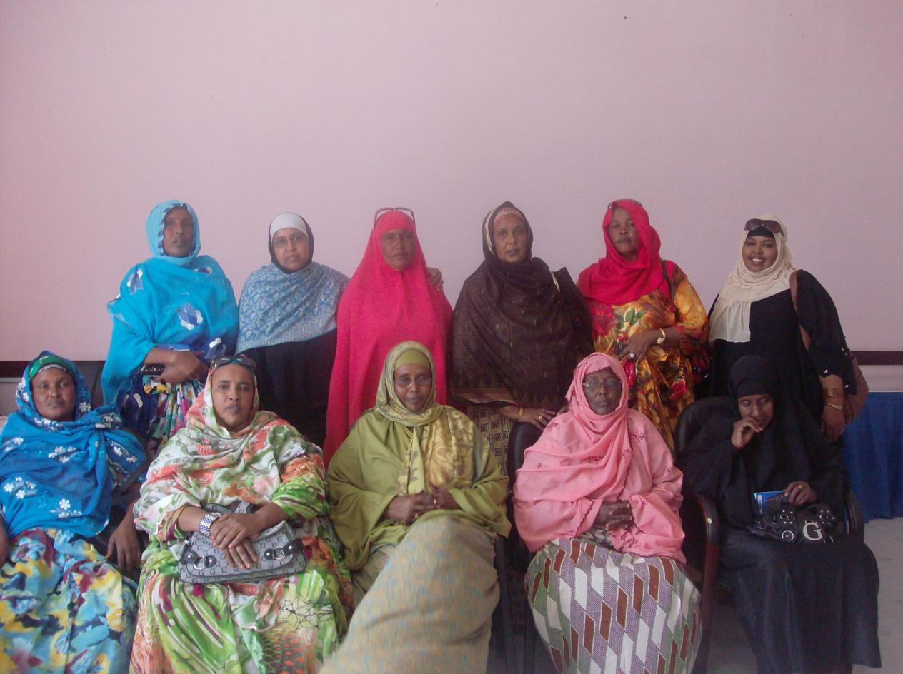

3. SPECIFC MEDIA ACTIVITIES

3.1 Media campaign messages through Radio Daljir
As was explained before, the media campaign occurred with the use of several; 2 radios and 1 television.

Below was the planned programme for the activities for Radio Daljir
Progaram | type | Time | Duration in air | Days | Date
1 | Discussion about the dev of education | 2:00PM | 15 Mints | 2 Days in a manth | 20/9/2011
2 | Spot messages | 7:20AM | 3 Mints | Daily | Daily
3 | Talk show | 9:00PM | 30 Mints | A DayA | 2//10/201
4 | Drama | 2:00AM | 30 Mints | A day | 5/11/2011

Radio discussions about the development of education

The activity on the discussion about the development of education was aired through the radio in the whole of punt land regions. The discussion was heard in every parts of punland the discussion was based a bout the challenges and obstacles towards education We made a discussion with some of educationist people in punt land and recorded their views

Sport message
Sport message was one of the greatest activity that we did during the on going programs and so far we have indicated the time the program was conducted
The same with other activity we have assigned aday for each program and the activity were carried nicely ,

3.2 Media campaign messages through Radio Garowe
Below was the planned program for the activities for Radio Garowe
Progaram | type | Time | Duration in air | Days | Date
1 | Discussion about the dev of education | 2:00PM | 15 Mints | 2 Days in a manth | 20/9/2011
2 | Spot messages | 7:20AM | 3 Mints | Daily | Daily
3 | Talk show | 9:00PM | 30 Mints | A DayA | 2//10/201
4 | Drama | 2:00AM | 30 Mints | A day | 5/11/2011

discussion about the development of eduvation

The activity on the discussion about the development of education was aired through the radio in the whole of punt land regions. The discussion was heard in every parts of punland the discussion was based a bout the challenges and obstacles towards education We made a discussion with some of educationist people in punt land and recorded their views

Sport message
Sport message was one of the greatest activity that we did during the on going programs and so far we have indicated the time the program was conducted
The same with other activity we have assigned aday for each program and the activity were carried nicely ,

3.3 Media campaign messages through SBC Television Network
This is the planned programme for the activities BC Television
Progaram | type | Time | Duration in air | Days | Date
1 | Discussion about the dev of education | 2:00PM | 15 Mints | 2 Days in a manth | 20/9/2011
2 | Spot messages | 7:20AM | 3 Mints | Daily | Daily
3 | Talk show | 9:00PM | 30 Mints | A DayA | 2//10/201
4 | Drama | 2:00AM | 30 Mints | A day | 5/11/2011

DEBATES
DRAMA

4. THE OUTPUTS AND OUTCOMES OF THE MEDIA CAMPAIGN

4. 1. Increased the number of benefited people in the states
4.2 Improved the education standard in the region
4. 3 Increased the understanding the importance of education

5. CONCLUSION AND RECOMMENDATIONS
Creating coordination committee on education department that evaluate the importance of this project. We recommend that with the help from unicef and the hard work from yhe ministry of education we can do better achievement We can say that the methodology that we aired through the radio were successful used properly by many people and had a strong impact in the organization of the activities. Thre is need to continue this project through the radio since it had been benefited by many people

